Experiment:- 13

Problem Statement:-
In Linux, automation of file and directory operations is a common requirement for system administration and scripting tasks. Bash scripting allows users to create files, copy content between files, extract specific portions of files, and compare files programmatically. These operations are frequently used in log management, data processing, and system maintenance.
The problem is to write a shell script that creates directories and files in the user’s home directory, copies content between files, prints content from a specific line onward, and displays differences between two files, thereby demonstrating file manipulation through shell scripting.

Aim:- Shell Script for file creation and manipulation using user directory.

Procedure
A. Writing the Shell Script
1. Open the terminal.
2. Create a script file: nano file_ops.sh

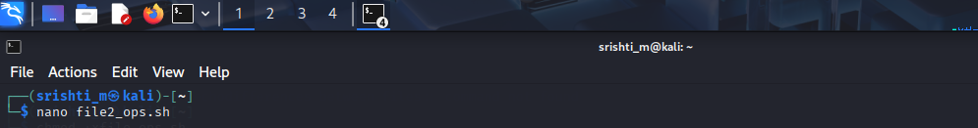

3. Enter the following script:
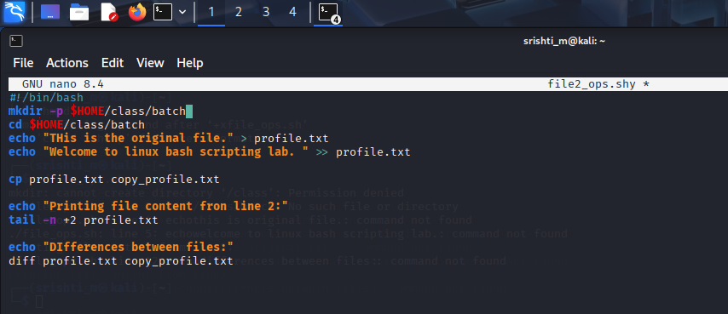

4. Save and exit the editor.
5. Make the script executable: chmod +x file_ops.sh
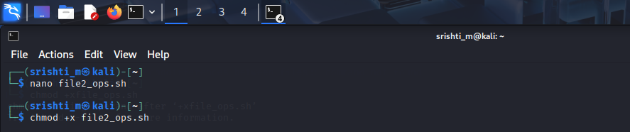

B. Executing the Script
6. Run the script:
7. ./file_ops.sh
